Task Report: Authentication Log Analysis (Kali Linux)
Objective
To analyze Linux authentication logs in Kali Linux to identify login activities and detect any failed or successful authentication attempts.

Environment Used
- Operating System: Kali Linux
- User: kali
- Log File Analyzed: /var/log/auth.log
- Tool Used: Terminal (grep command)
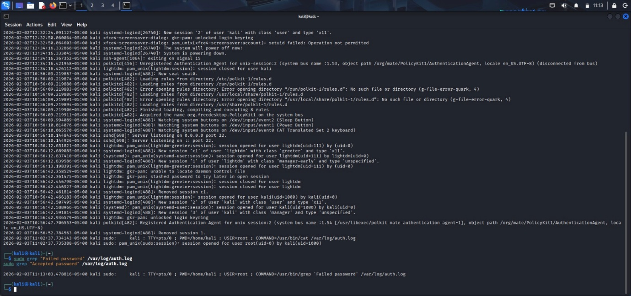

Commands Used
sudo grep "Failed password" /var/log/auth.log sudo grep "Accepted password" /var/log/auth.log

Observations
- The system log shows multiple system startup and shutdown events.
- SSH service is running and listening on port 22.
- Login sessions were created for:
  - kali user
  - lightdm greeter session
- The command
grep "Failed password"
returned no output, which indicates:
  - ✅ No failed login attempts detected.
- The command
grep "Accepted password"
confirms:
  - ✅ Successful authentication via sudo
  - User kali successfully accessed root privileges.
Result
- No suspicious or unauthorized login attempts were found.
- System authentication appears secure and normal.
- Only legitimate user activity is recorded.

Conclusion
The authentication logs indicate a secure system state with no failed password attempts. Monitoring auth.log is an effective method to detect brute-force attacks and unauthorized access attempts in Linux systems.

